**A. Revision for Summary of Sales**

1. Some amounts were replaced with “#” because the columns were not wide enough to reflect the whole amount.

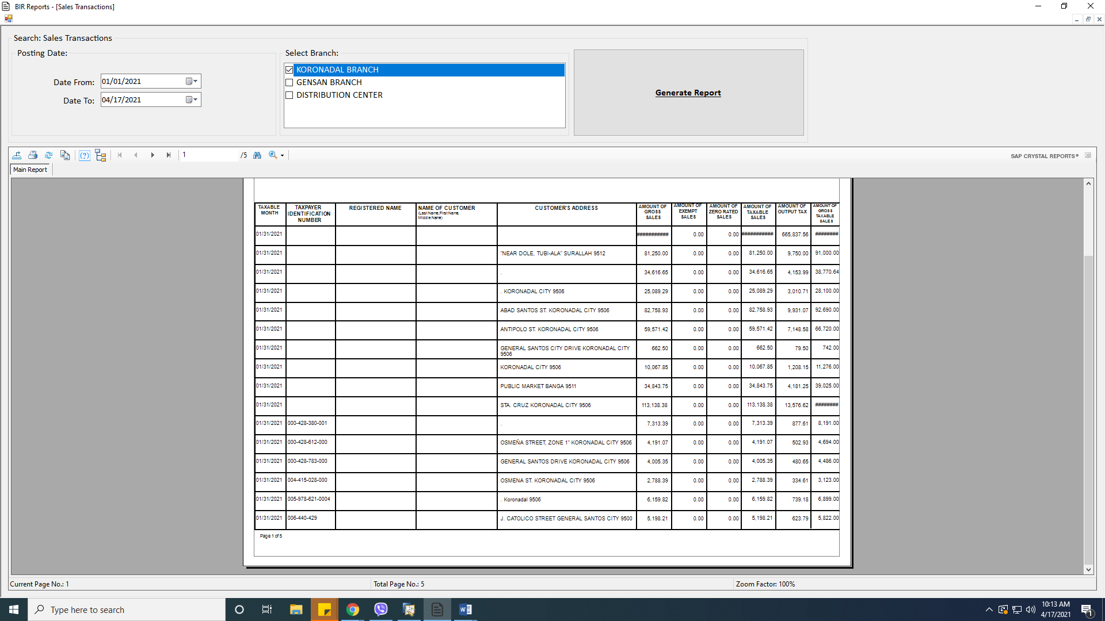

2. The report should be able to reflect the TIN number from the AR Invoice or AR Reserve, especially for walk-in customers. Please also take note that neither of the company names nor the company owners were reflected in the report.

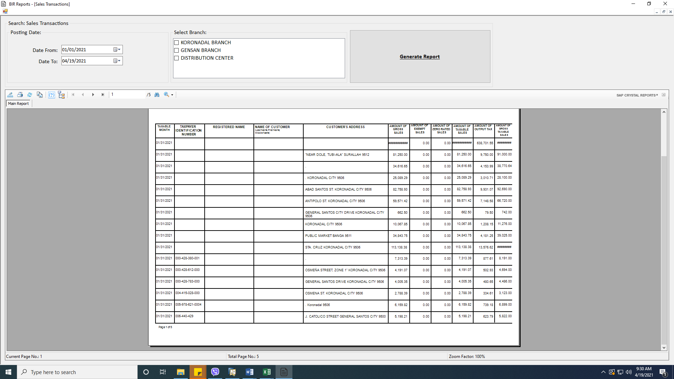

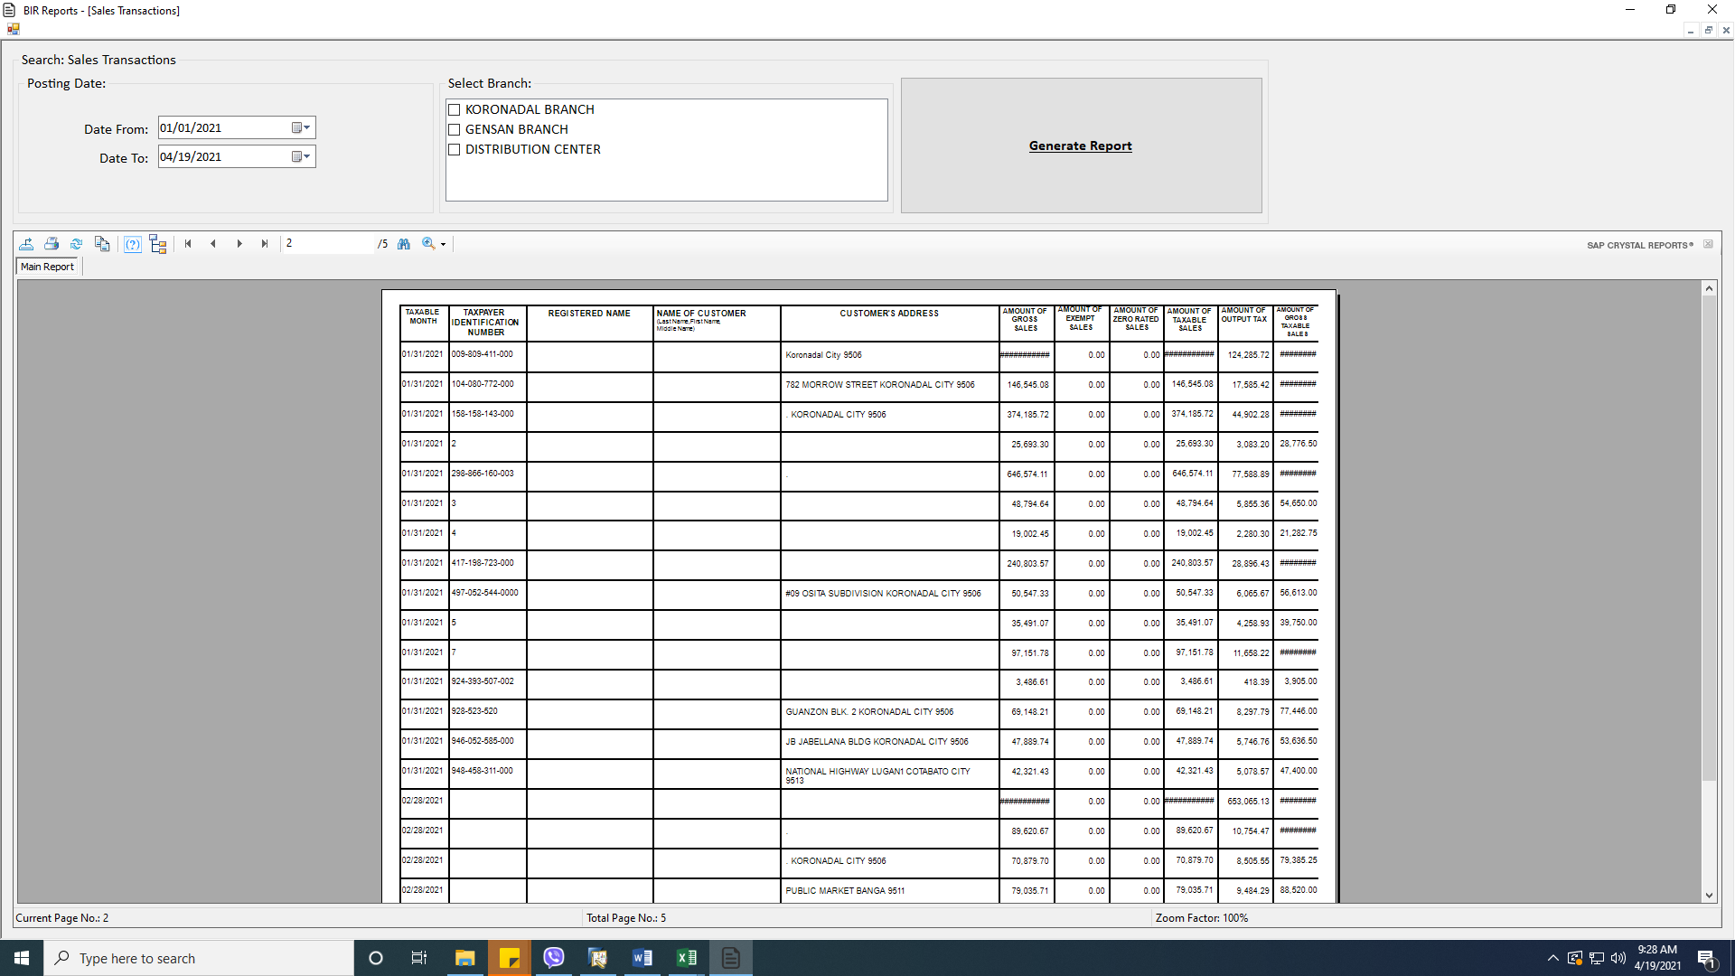

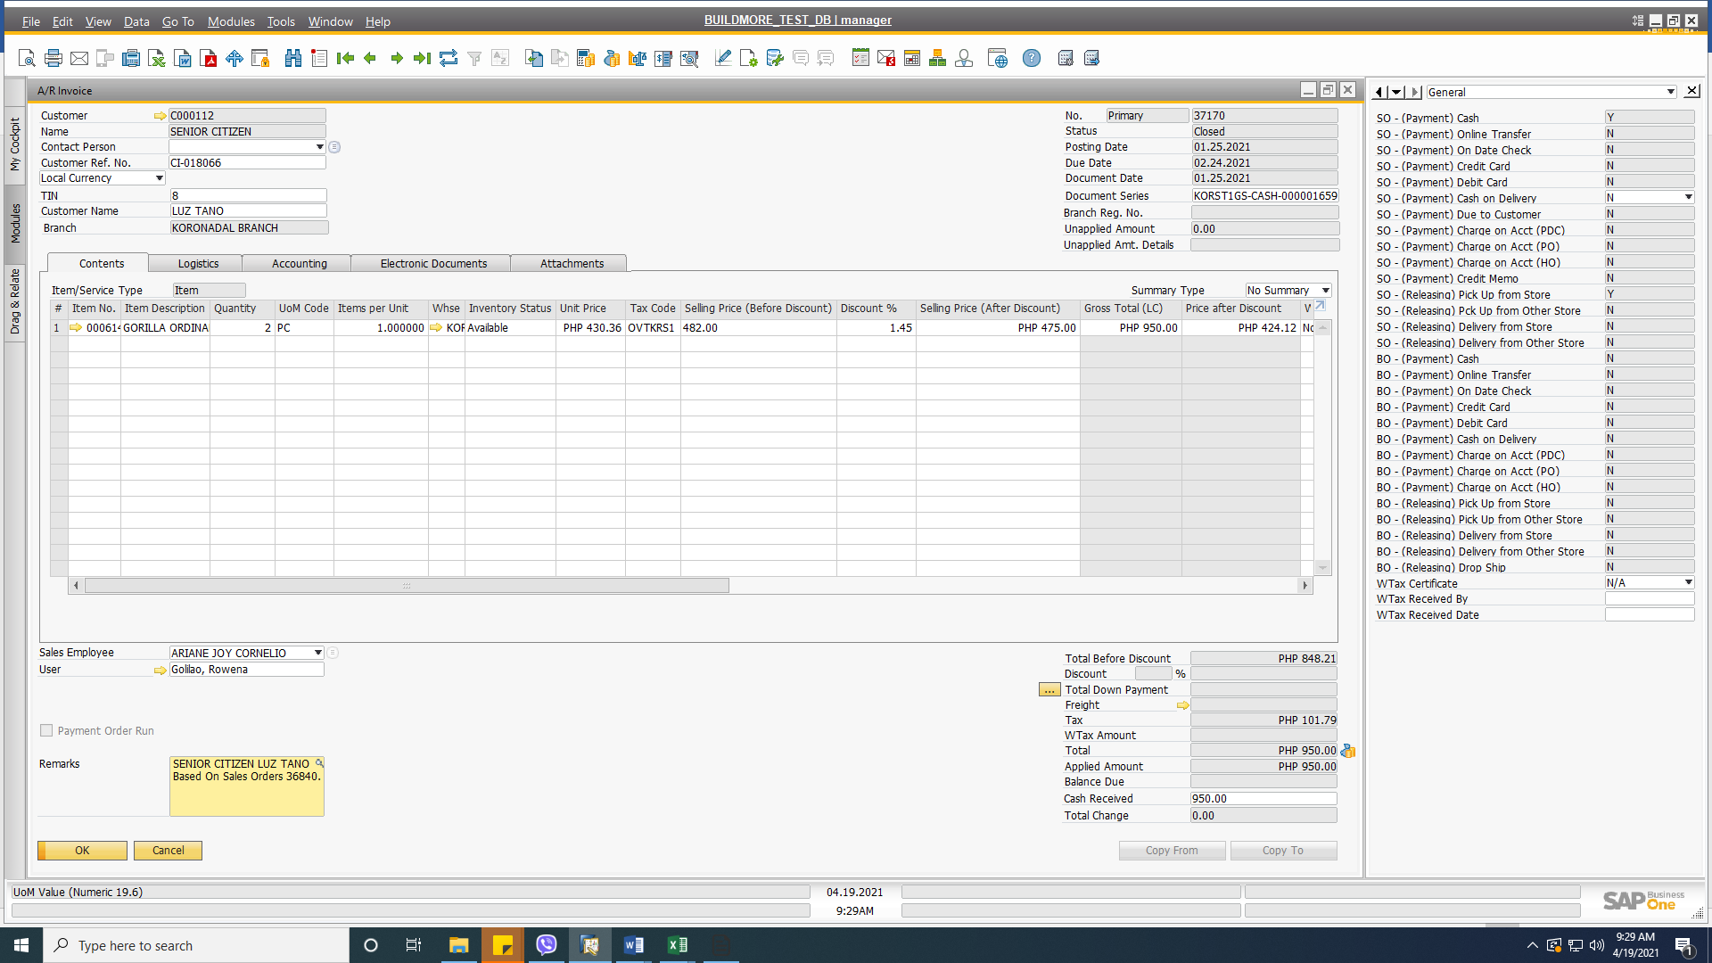

3. There is a discrepancy of 2,752.45 in the 2021 report. The possible reason might be from these transactions.

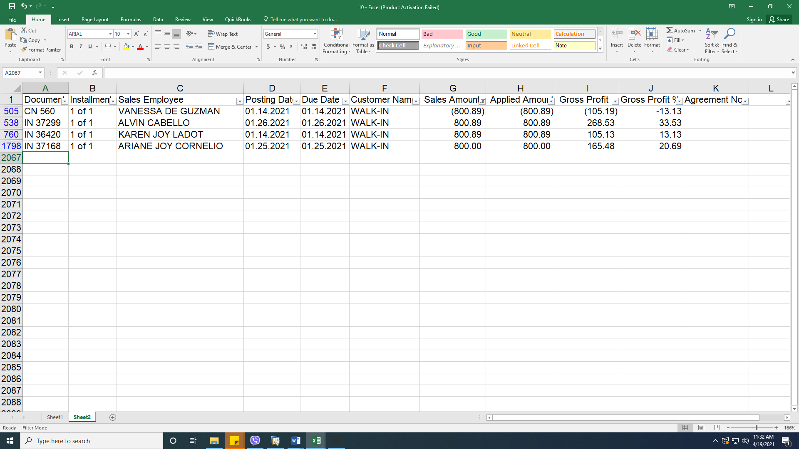

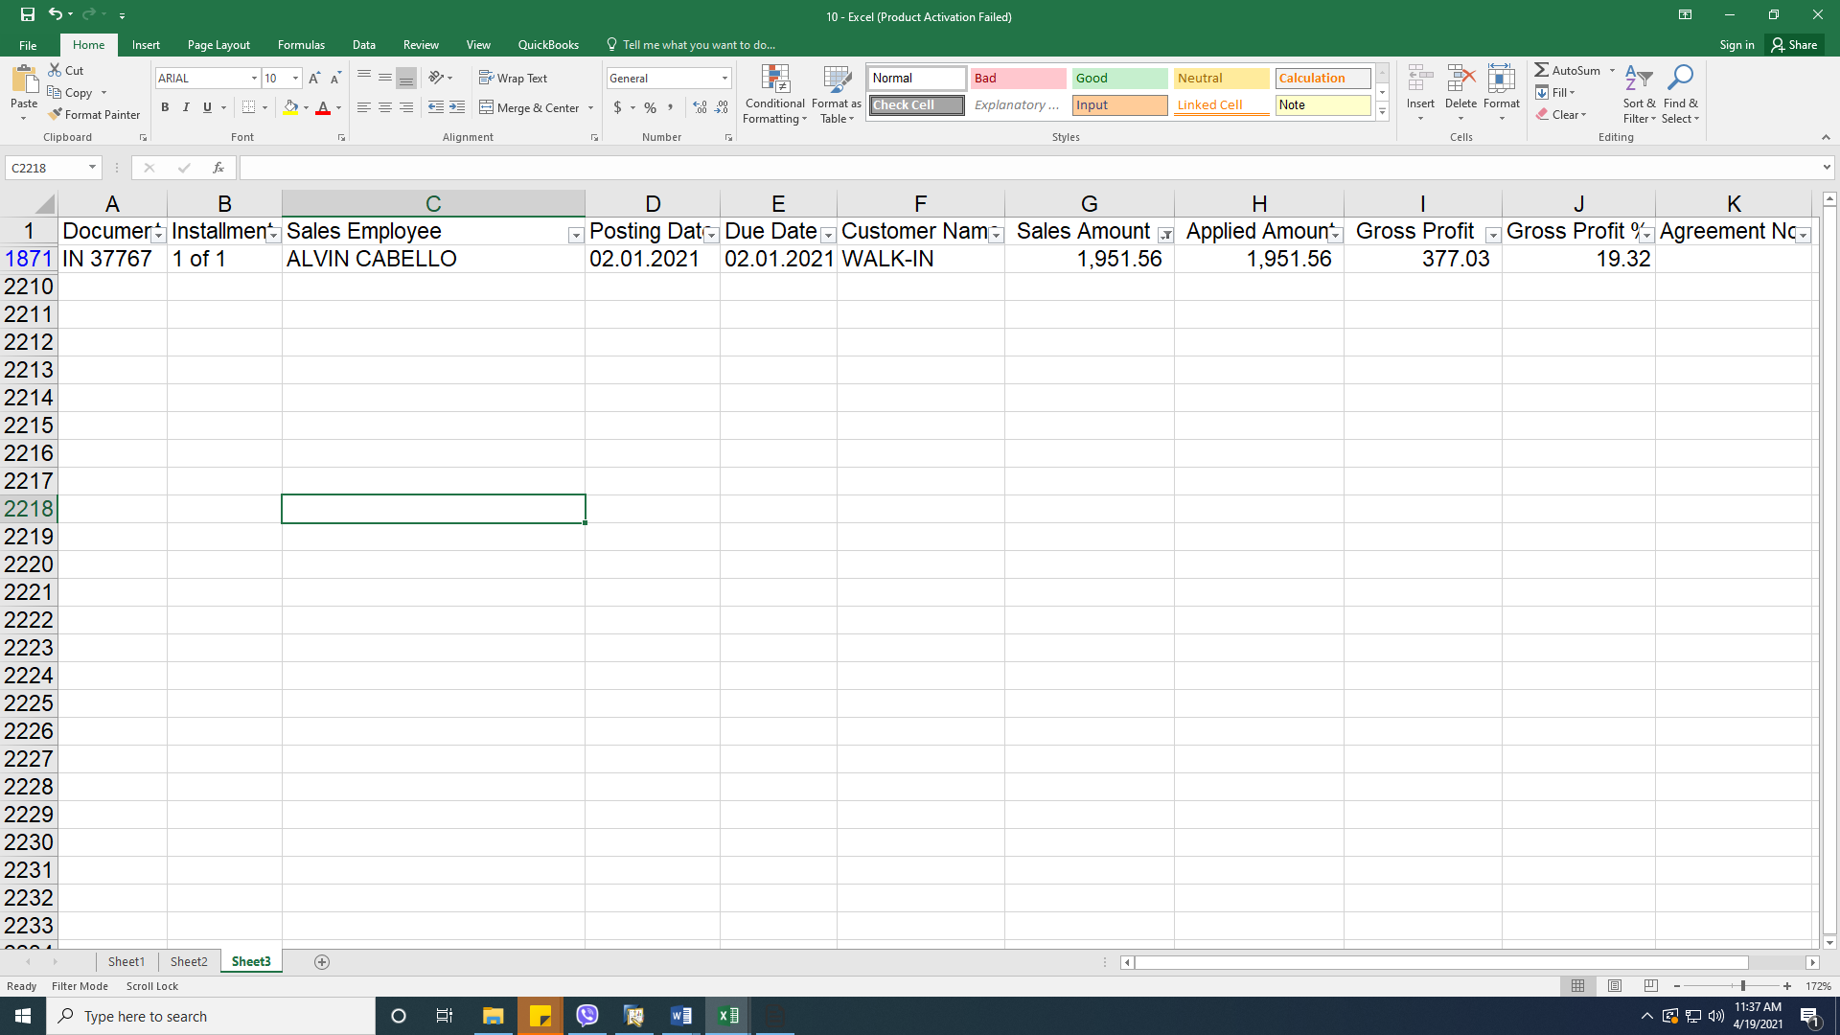

4. There is a discrepancy of 15,198.55 in the 2020 report. The possible reason might be from these transactions.

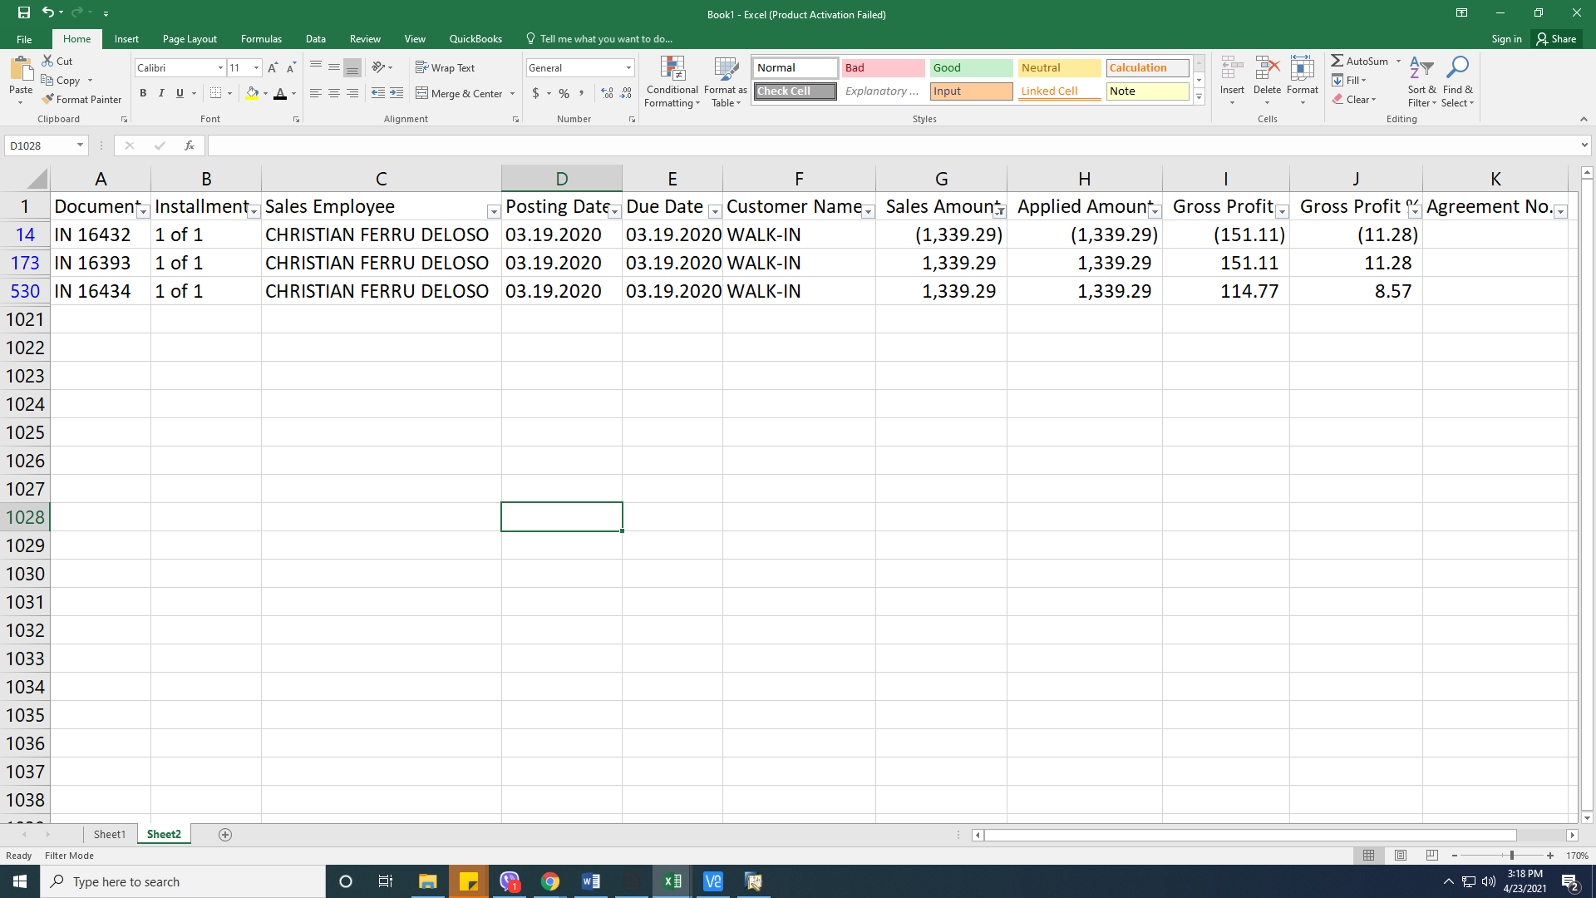

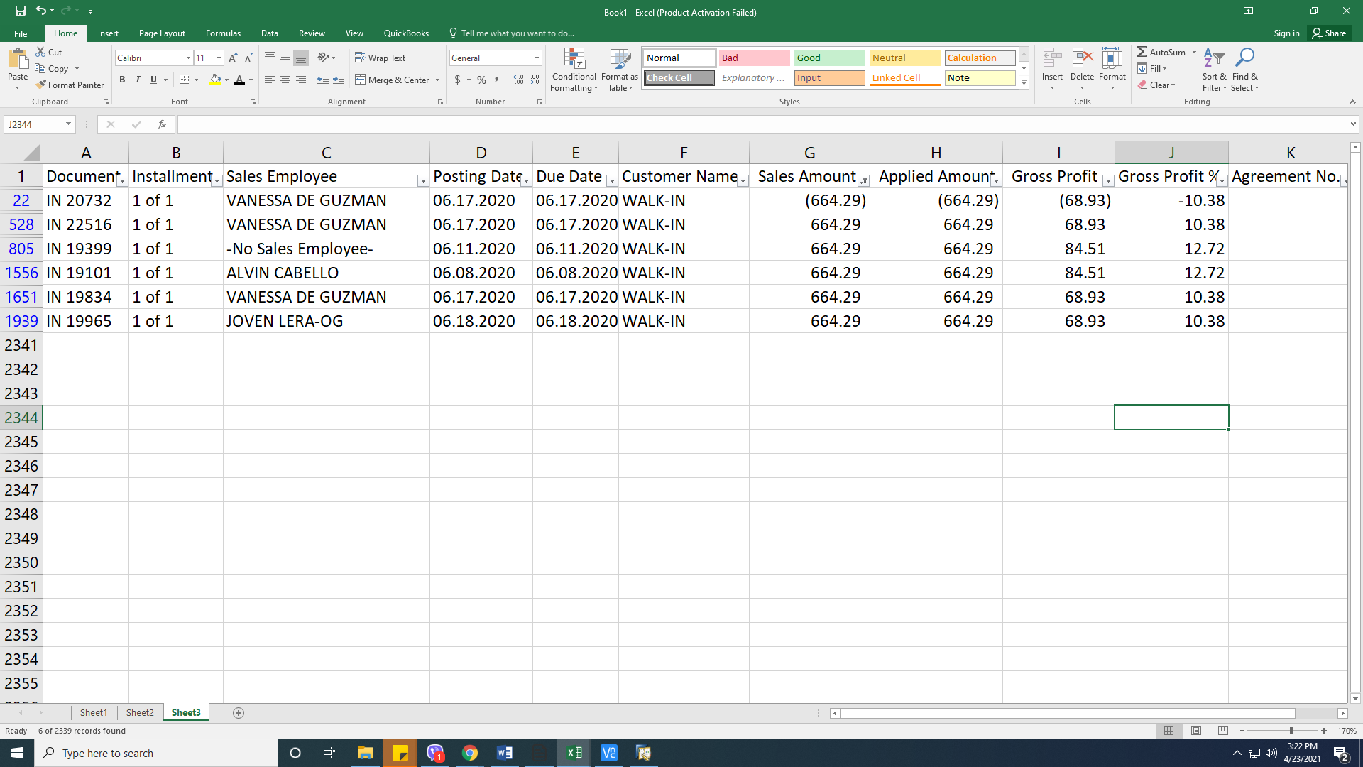

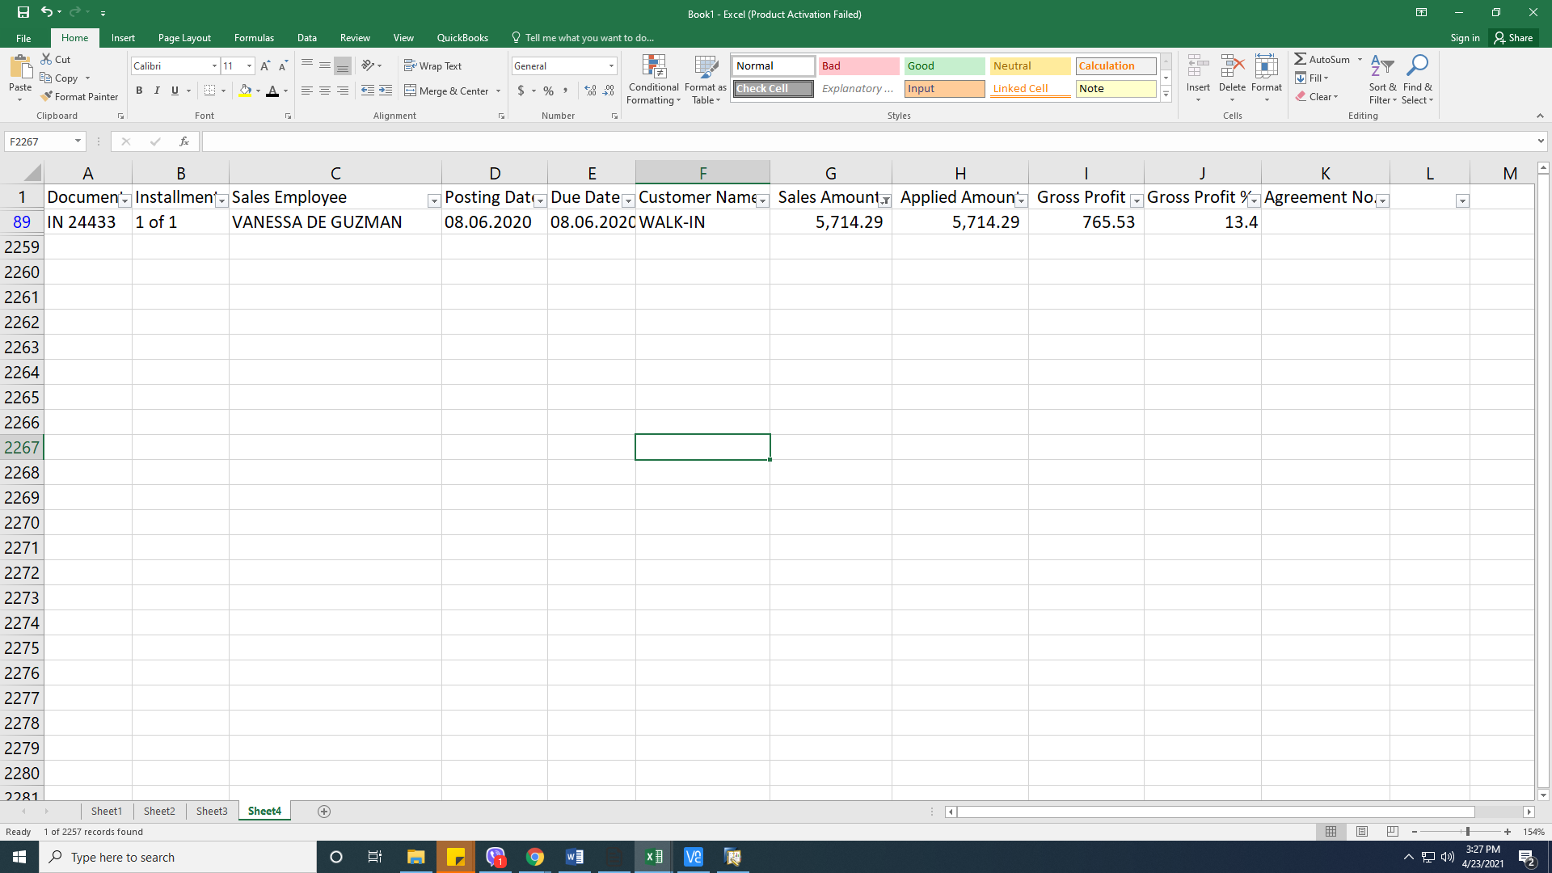

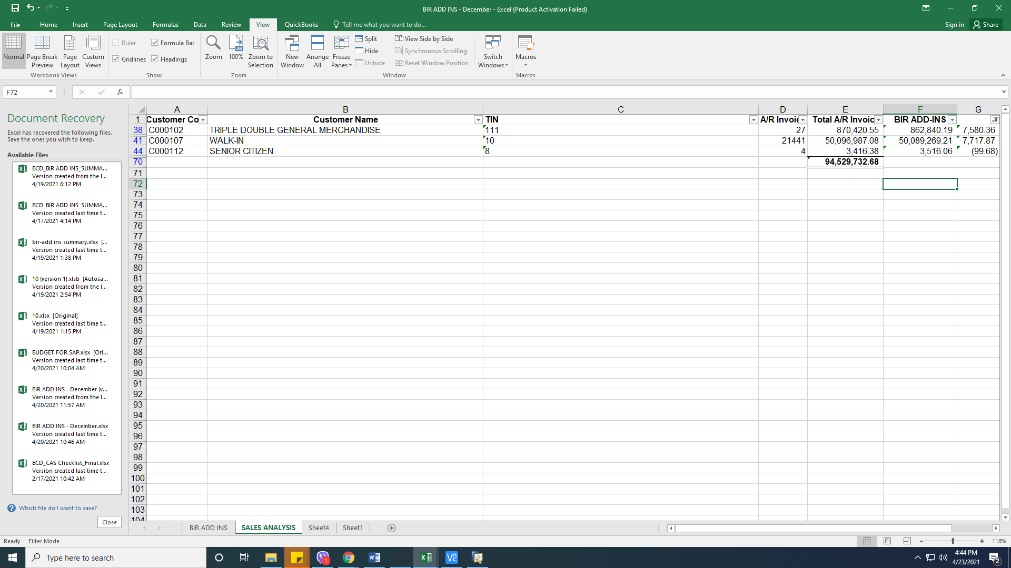

**B**. **Revision for Summary of Purchasing**

1. The Petty Cash transactions (Maria Bianca King and Shing Hwai King) should not be included in the report unless a name is inputted in the AP Invoice User Defined Field.

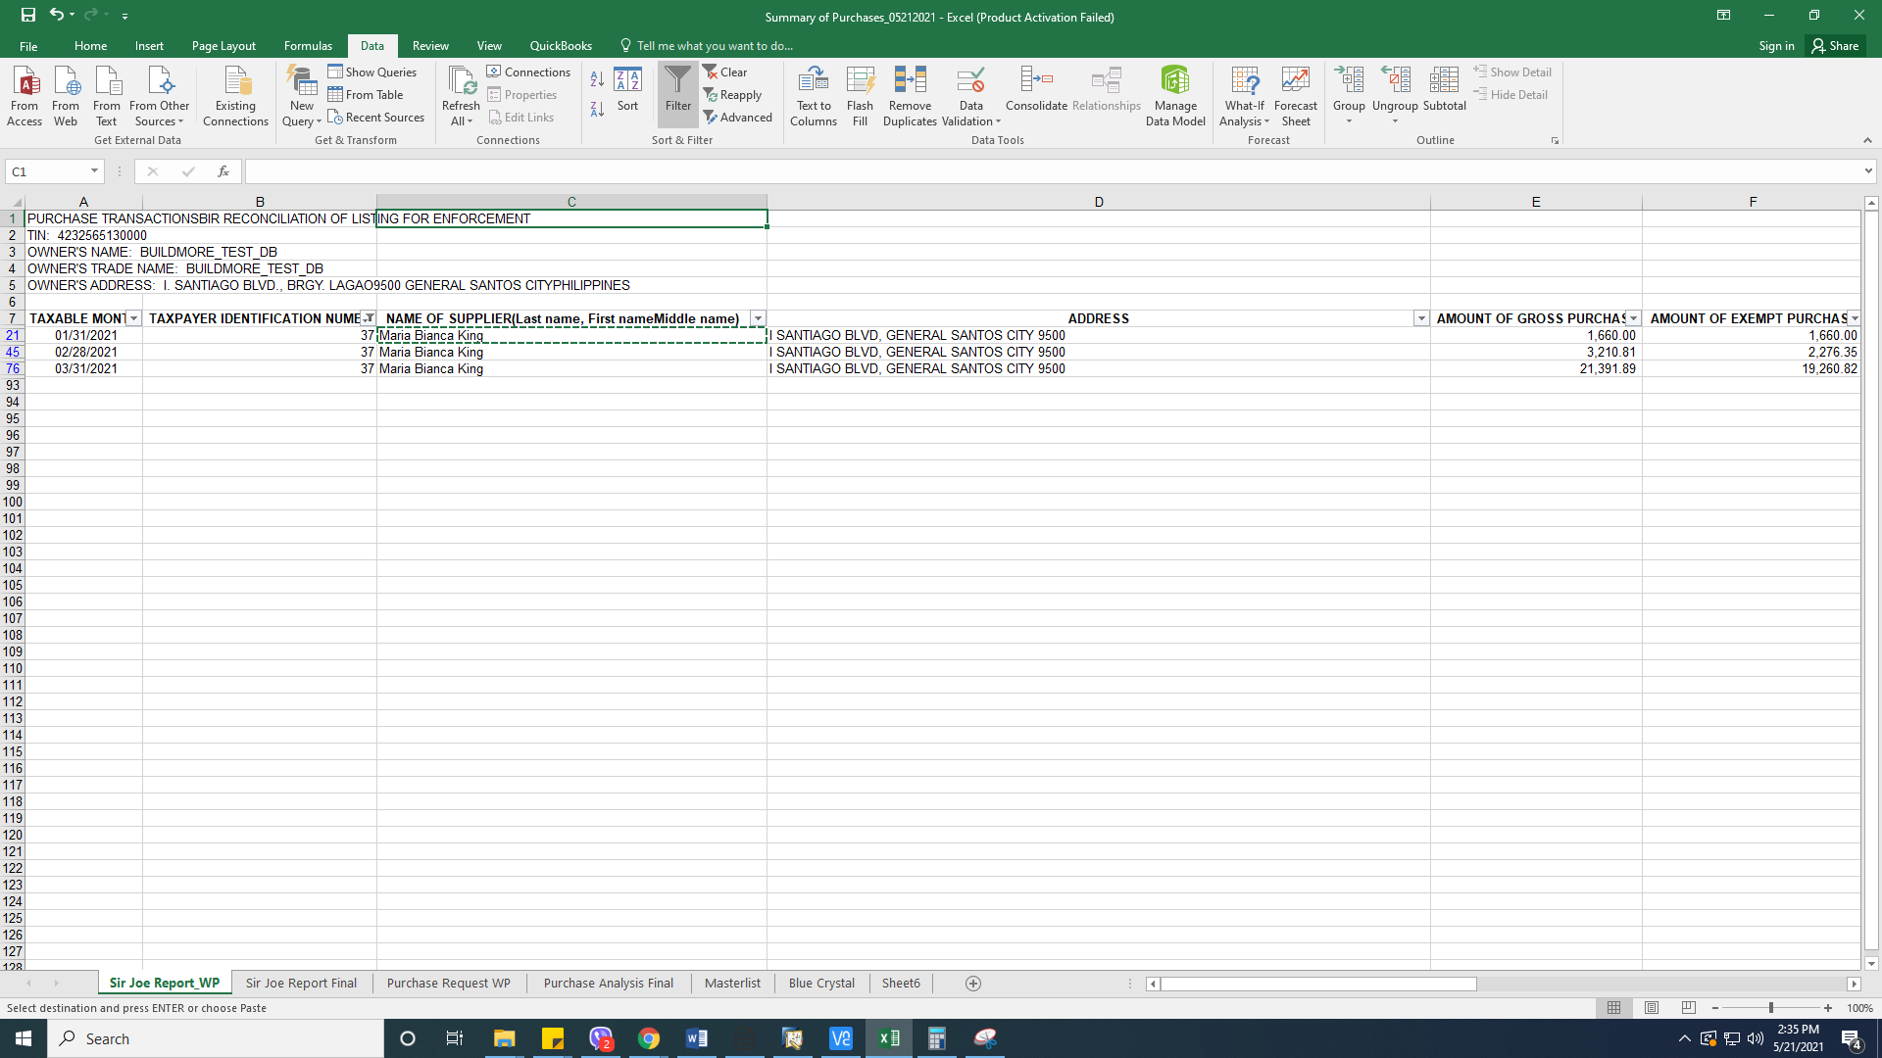

2. Please take note that neither of the registered names nor the name of suppliers were reflected in the report.

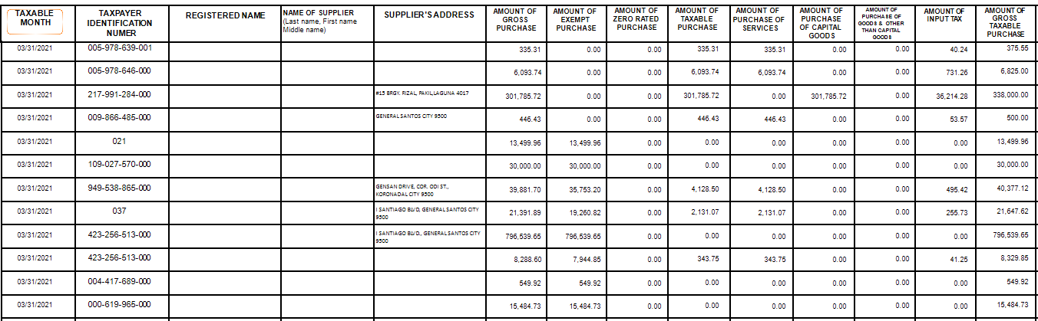

3. Advance Payment should not be included in the report. 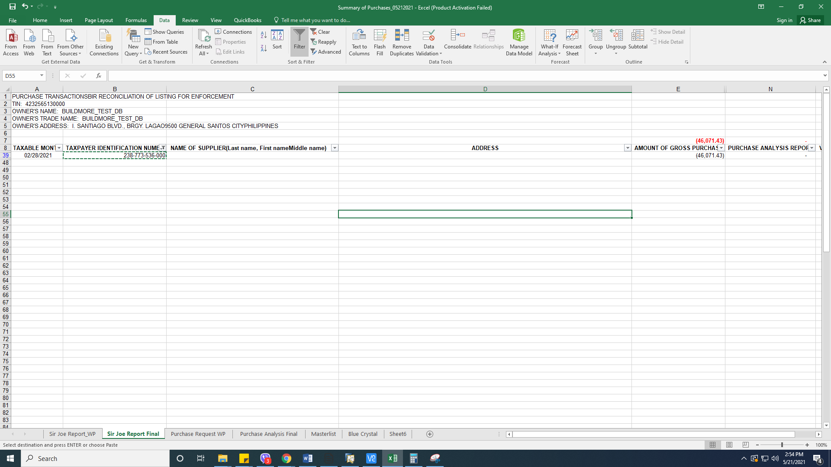

4. Vat Exempt Transactions should not be included in the Amount of Gross Taxable Purchase.

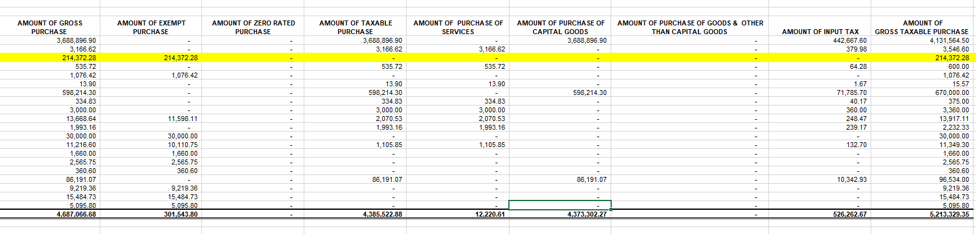

**C. Revision for Cash Receipt Journal**

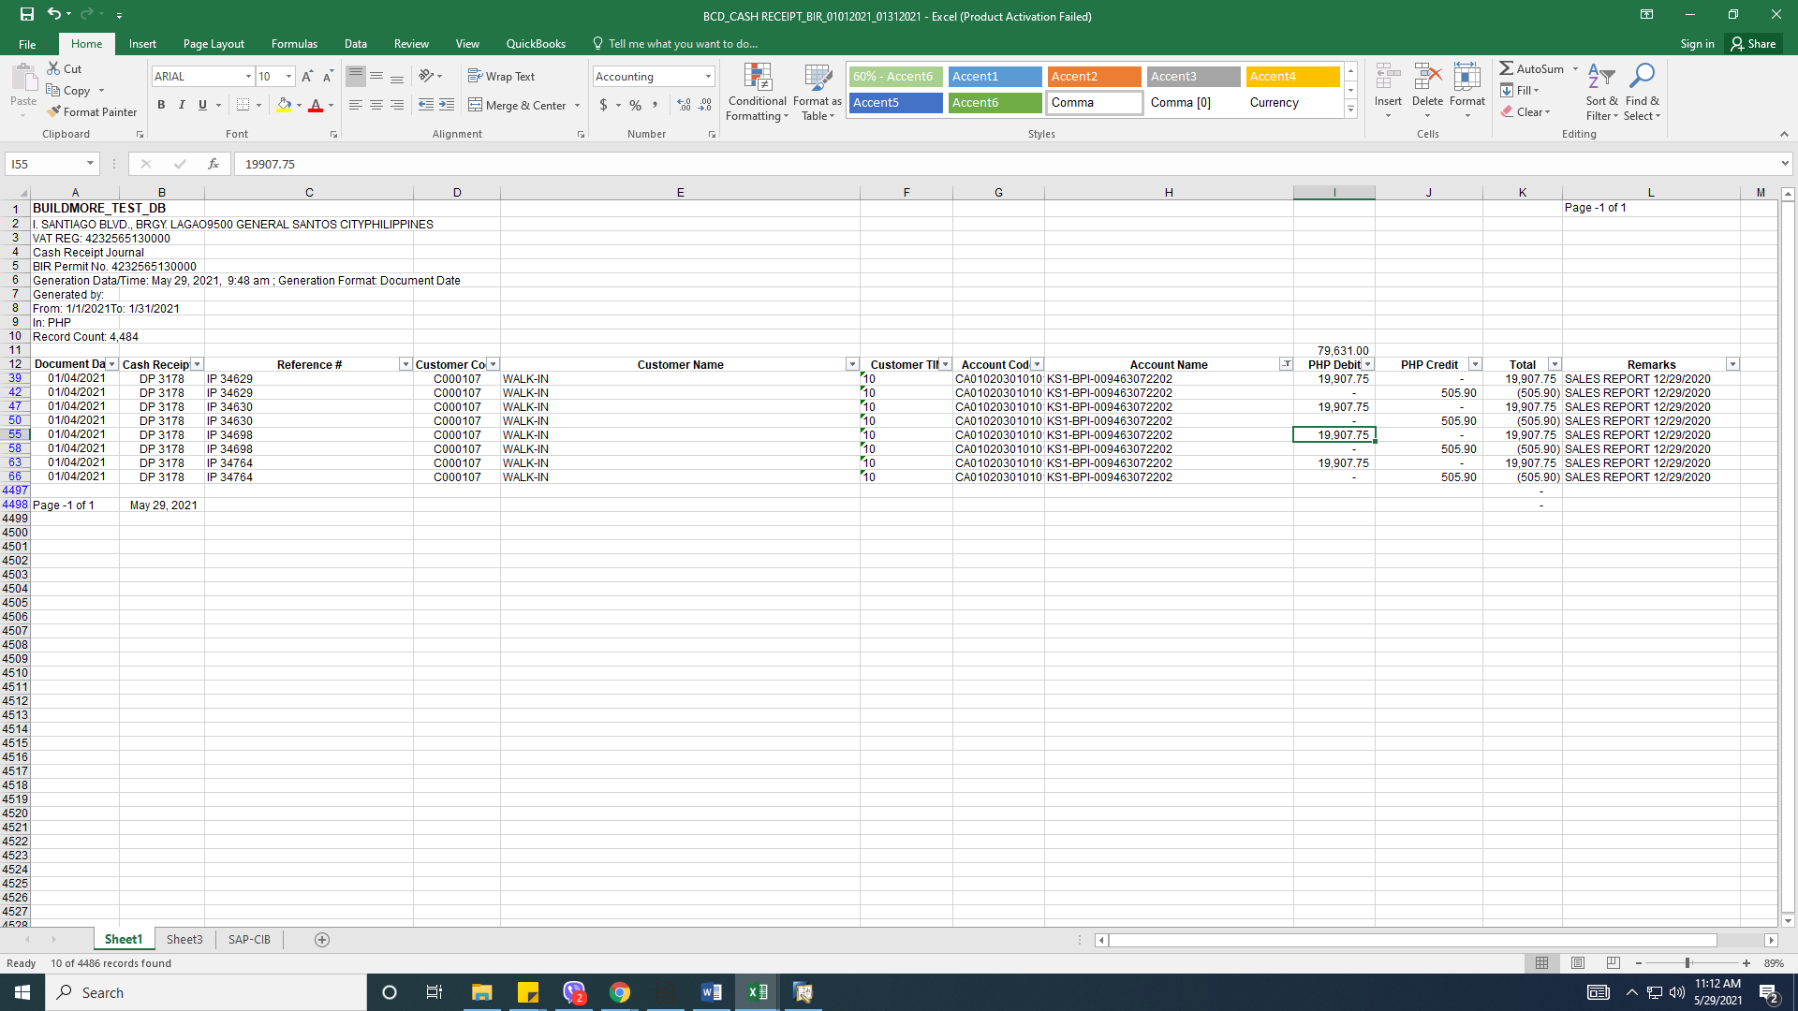1. Duplication of transactions.

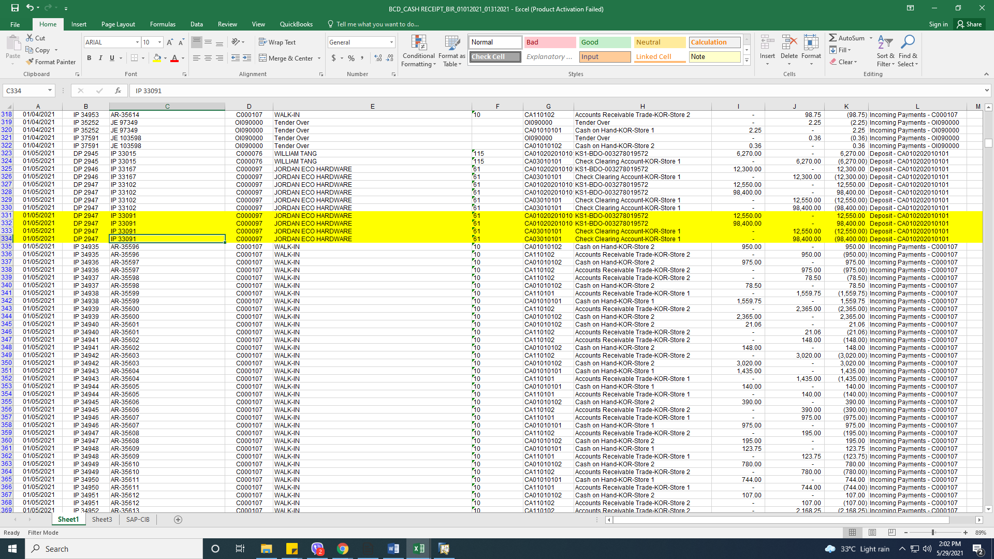

**2. SUGGESTION ONLY:** Use the code “RC” for Incoming Payments. That is the default code in SAP not “IP”.

3. Cancelled transaction should not be included in the report.



4. Recognition of Bank Charges should be included in the General Journal.



5. For mixed transactions, only cash related transactions should be recognized immediately. Clearing accounts should not be included.

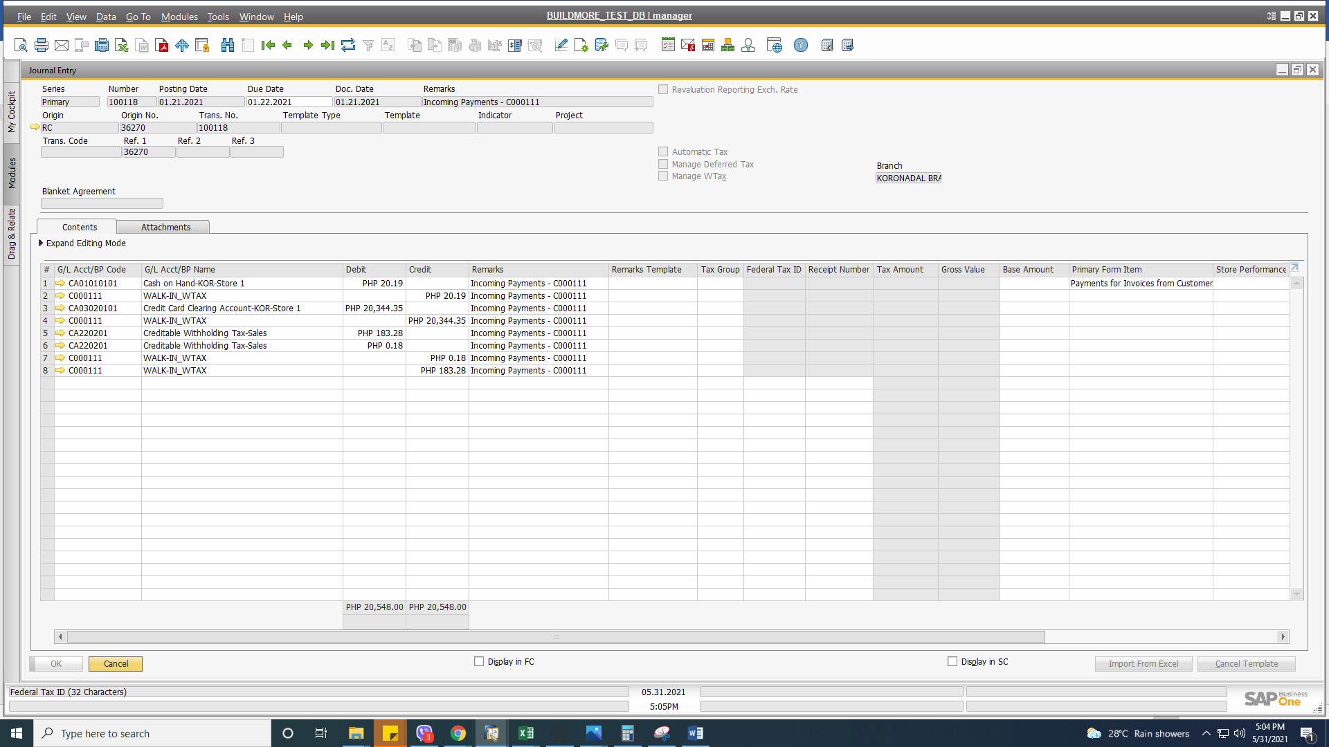

**D. Cash Disbursement Journal**

1. Outgoing Payment using Cash Tab should be included in the Cash Disbursement Journal.